

Department of Computer Science and Engineering
Course Code & Name | CSA06 – Design and Analysis of Algorithms
Assessment | CO1 – Assessment Tool 1: IT Application-Based Problem Solving – Scalability Audit of an E-Commerce Platform
Course Outcome Assessed | Determine algorithm efficiency using asymptotic notations and mathematical techniques including Master Theorem and substitution method.
Duration | 3 Days
Mode | Individual
Student Reg. No. | 192472347
Student Name | N.Somasekhar Naidu
Instructions: Answer all parts. Show the basic operation, every step of each derivation and the final asymptotic result, and interpret what each result means for the platform. Assume the platform’s servers execute 10 basic operations per second.

IT APPLICATION-BASED PROBLEM
Scenario – Scalability Audit of “ShopSphere”, an Online Shopping Platform: ShopSphere is a growing e-commerce platform whose product catalogue currently holds n = 100,000 products and is expected to reach n = 1,000,000 within a year. Before the expansion, the CTO has asked you, as the platform’s algorithm engineer, to audit five back-end modules, predict how each will behave as n grows, and recommend which modules must be redesigned. The modules are described below.
Module M1 – Duplicate-Listing Detector: Sellers sometimes upload the same product twice. Every night, the following routine compares every product with every later product.
FOR i ← 0 TO n − 2 DO
FOR j ← i + 1 TO n − 1 DO
IF Product[i].title = Product[j].title AND Product[i].seller = Product[j].seller THEN
MarkDuplicate(j) END IF
END FOR END FOR

Module M2 – API Rate Limiter: The public API audits request windows of doubling size using the routine below. A team member claims that it is Θ(n log n) because the outer loop runs about log n times and the inner loop runs up to n times.
i ← 1
WHILE i < n DO
FOR j ← 0 TO i − 1 DO
Audit(Request[j]) END FOR
i ← i × 2 END WHILE
// basic operation

Module M3 – Product Search: Two versions exist. Version S1 scans the unsorted catalogue sequentially until the product is found. Version S2 searches a sorted product index by comparing the key with the middle entry and discarding half the index after each comparison; its comparison count satisfies T(n) = T(n/2) + 1, T(1) = 1.
Module M4 – Recommendation Engine: The engine splits the customer–product data into four parts of size n/2 (because of replicated partitions) and merges the partial results in linear time: T(n) = 4T(n/2) + n. A proposed redesign removes the replication, giving T(n) = 2T(n/2) + n.
Module M5 – Sales Analytics Engine: The analytics engine splits the sales data into halves recursively and sorts the records by revenue at every level, giving T(n) = 2T(n/2) + n log n. Separately, profiling shows that the nightly report generator performs f(n) = 3n² + 10n log n + 50 operations.
- Understand the Problem: For each of the five modules, identify the input size and the basic operation that dominates the running time, explain where it occurs, and state how you expect its execution count to grow as n increases. Justify each choice briefly.
- Analyse the Iterative Modules: For M1, derive the exact number of comparisons as a function of n and state the time and space complexity. For M2, derive the exact number of Audit operations, decide whether the team member’s Θ(n log n) claim is correct and give the tight bound. Verify your M2 result for n = 1,024.
- Solve a Recurrence by Substitution: Solve the recurrence for search version S2 using backward substitution, showing every intermediate step, and derive the exact closed form. State the time complexity and the space complexity of both an iterative and a recursive implementation.
- Apply the Master Theorem: For M4, apply the Master Theorem to both the current design and the proposed redesign, clearly identifying a, b, f(n), n^(log_b a) and the case used, and explain what happens to the running time when the data doubles. For M5, determine whether any of the three standard cases applies to T(n) = 2T(n/2) + n log n; if not, derive the complexity using the extended Master Theorem or a recursion tree.
- Analyse Best, Average and Worst Cases: For search versions S1 and S2, identify the input condition that produces the best, average and worst case and give the number of comparisons in each. For S1, derive the average number of comparisons when the probability that the searched product exists is p, and evaluate it for n = 1,000,000 and p = 0.5.
- Prove an Asymptotic Bound: Using the formal definitions, prove that the report generator’s cost f(n) = 3n² + 10n log n + 50 is Θ(n²) by finding constants c , c and n , and show that f(n) is not O(n).
- Scalability Decision: Estimate the number of basic operations and the running time of M1, M2, S2, M4 (both designs) and M5 for n = 1,000,000. Identify the modules that will fail to meet a nightly processing window of 10 minutes, and recommend, with justification, which modules must be redesigned and how.

Rubrics – Application-Based Question

Criteria | Weightage (%) | Level 4 – Exemplary | Level 3 – Proficient | Level 2 – Developing | Level 1 – Beginning
Understanding of Problem Context | 20 | Clearly understands the problem and accurately identifies all requirements | Good understanding with minor gaps | Basic understanding; some requirements unclear | Poor understanding or misinterpretation of the problem
Application of Concepts | 30 | Accurately applies appropriate concepts to solve complex problems | Applies relevant concepts correctly with minor errors | Applies basic concepts with limited accuracy | Fails to apply appropriate concepts
Problem-Solving Approach | 20 | Logical, well-structured, and efficient approach | Mostly logical approach with minor gaps | Basic approach with some inconsistencies | Illogical or unclear approach
Accuracy of Solution | 20 | Completely correct solution with proper justification | Mostly correct with minor errors | Partially correct solution | Incorrect or incomplete solution
Clarity | 10 | Clear, well-organized, and properly explained solution | Understandable with minor clarity issues | Limited clarity and explanation | Poorly presented and difficult to understand

Mark Evaluation:
Criteria | Weightage (%) | Level 4 – Exemplary | Level 3 – Proficient | Level 2 – Developing | Level 1 – Beginning
Understanding of Problem Context | 20
Application of Concepts | 30
Problem-Solving Approach | 20
Accuracy of Solution | 20
Clarity | 10
Total Marks

Code of Conduct
I N.Somasekhar Naidu(192472347) (Name / Reg. No.) certify that this submission is my original work and that I have adhered to the guidelines specified for this assessment. I understand that any violation of academic integrity rules will result in disciplinary action.
Signature of the Student: N.Somasekhar Naidu Date: 20-10-2026

TASK 1 — Algorithmic Strategy Design & Pseudocode
To evaluate the search space and back-end modules of the ShopSphere platform, three fundamentally distinct algorithmic paradigms are designed and investigated. These strategies differ in conceptual approach, data structure requirements, and mathematical complexity.

Approach 1: Iterative Linear Search (Sequential Brute-Force Scanning)
Design Paradigm: Brute Force / Exhaustive Sequential Scanning.
Basic Idea: The algorithm sequentially examines every record starting from index 0 through index n - 1 in an unsorted array, comparing the target key against each record's key until a match is found or the end of the array is reached.
Preprocessing Requirements: Absolutely None. The dataset is ingested in arrival/arbitrary order (T_prep(n) = 0).
Justification for Selection: Serves as the universal algorithmic baseline. While computationally expensive on large collections (O(n)), it incurs zero upfront setup cost and zero auxiliary memory overhead, making it ideal for one-off searches.
Algorithm LinearSearch(records[0..n-1], target_reg_no):
1. comparisons <- 0
2. for i <- 0 to n - 1 do:
3. comparisons <- comparisons + 1
4. if records[i].reg_no == target_reg_no then: // BASIC OPERATION
5. return (records[i], comparisons)
6. return (None, comparisons)

Approach 2: Recursive Binary Search (Divide-and-Conquer)
Design Paradigm: Recursive Divide-and-Conquer.
Basic Idea: Operates on a contiguous array sorted monotonically by registration number. The algorithm probes the middle element. If the target matches, search terminates; if target is smaller, it recursively divides the search domain in half to the left subproblem [low..mid-1]; otherwise, it recurses into the right subproblem [mid+1..high].
Preprocessing Requirements: Mandatory sorting by registration number. Executed via Timsort/Merge Sort in O(n log n) time and O(n) auxiliary space.
Justification for Selection: The canonical comparison-based search algorithm with logarithmic time complexity (O(log n)). Provides deterministic upper bounds, minimal runtime overhead, and zero extra dynamic memory structures.

Algorithm BinarySearchRecursive(records[0..n-1], target, low, high, comps):
1. if low > high then return (None, comps) // Base Case: Key absent
2. mid <- low + floor((high - low) / 2)
3. comps <- comps + 1
4. if records[mid].reg_no == target then: // BASIC OPERATION
5. return (records[mid], comps)
6. else if target < records[mid].reg_no then:
7. return BinarySearchRecursive(records, target, low, mid - 1, comps)
8. else:
9. return BinarySearchRecursive(records, target, mid + 1, high, comps)

Approach 3: Chained Hash Table (Direct Hashing / Key-to-Address Transformation)
Design Paradigm: Direct Addressing / Hashing with Collision Resolution.
Basic Idea: Maps the 9-digit registration number directly to a bucket array index via Knuth Multiplicative Hashing: h(k) = ((k * A) mod 2^32) mod m. Collisions are resolved through Separate Chaining (singly-linked bucket lists). Looking up a student requires hashing the key in O(1) time and scanning the short linked chain.
Preprocessing Requirements: Initial hash table allocation of capacity m = ceil(n / 0.70) buckets and bulk insertion of all n records in O(n) time.
Justification for Selection: Achieves expected constant-time retrieval (O(1)) independent of dataset size n. This non-comparison paradigm is critical for high-throughput enterprise workloads where millions of queries must be served.
Algorithm HashTableSearch(Table, target_reg_no):
1. comps <- 0
2. index <- Hash(target_reg_no, Table.capacity) // O(1) hash evaluation
3. curr <- Table.buckets[index]
4. while curr != NULL do:
5. comps <- comps + 1
6. if curr.record.reg_no == target_reg_no then: // BASIC OPERATION
7. return (curr.record, comps)
8. curr <- curr.next
9. return (None, comps)

TASK 2 — Basic Operation Identification & Justification
Algorithm | Basic Operation | Code Location | Theoretical Scaling C(n)
Linear Search (Iterative) | Equality comparison between record key and target key | if records[i].reg_no == target: | Linear: C(n) = n (worst), (n+1)/2 (avg)
Binary Search (Recursive) | Three-way key comparison (target vs records[mid]) | if records[mid].reg_no == target: | Logarithmic: C(n) = floor(log2 n) + 1 (worst)
Hash Table (Chained) | Key equality check during bucket chain traversal | if curr.record.reg_no == target: | Constant: C(n) = 1 + alpha/2 ~ 1.35 (avg)
In-Depth Justification for Selection of the Basic Operation:
1. Dominance of Computational Time: In algorithm analysis, the basic operation is defined as the operation within the innermost loop or recursive call that contributes the most to the total running time. Pointer offsets and index increments execute in fixed cycles; key comparisons dictate branching and termination.
2. Invariance to Machine Architecture: While CPU cycles per instruction fluctuate across microarchitectures (cache hits vs misses), the count of key comparisons C(n) provides an objective, machine-independent metric.
3. Scaling Behavior with n: As n expands from 10^3 to 10^6, Linear Search comparisons increase 1,000-fold; Binary Search increases by only 10 operations (10 to 20); Hash Table remains strictly bounded around 1.35 operations.

TASK 3 — Mathematical Time-Complexity Derivation
Let n denote the total number of records in the database. Below is the rigorous step-by-step mathematical derivation for each strategy:
1. Mathematical Derivation for Iterative Linear Search:
In an array of n elements, let p be the probability that the search key is present (0 <= p <= 1). Assuming a uniform distribution where any present element is equally likely to reside at any index i in {0, ..., n-1}, P(i) = p / n. If absent (probability 1 - p), exactly n comparisons are executed.
C_worst(n) = n
C_best(n) = 1
C_avg(n) = sum_{i=1}^n [ i * P(i) ] + n * (1 - p)
= (p / n) * [ n(n + 1) / 2 ] + n(1 - p)
= p * (n + 1) / 2 + n(1 - p) = [n(2 - p) + p] / 2
For successful search (p = 1): C_avg(n) = (n + 1) / 2 in Theta(n).
2. Mathematical Derivation for Recursive Binary Search:
Binary search halves the search space at each iteration: n/2^k = 1 ==> 2^k = n ==> k = log2 n.
Total comparisons in worst-case: C_worst(n) = floor(log2 n) + 1 in Theta(log n).
Average Case via Decision Tree: Depth h = ceil(log2 n). Expected comparisons: C_avg(n) ~ log2 n - 1 in Theta(log n).
3. Mathematical Derivation for Chained Hash Table:
Expected bucket chain length E[len] = n / m = alpha (load factor = 0.70).
Unsuccessful Search: C_unsuccessful(n) = alpha comparisons in Theta(1 + alpha).
Successful Search: C_avg(n) = 1 + alpha / 2 = 1 + 0.70 / 2 = 1.35 comparisons in Theta(1).

TASK 4 — Best, Average, and Worst-Case Analysis
Algorithm | Case | Exact Input Condition | Comparisons C(n) | Time Complexity
Linear Search | Best | Target is at index 0 of array | 1 | Omega(1)
Linear Search | Average | Target uniformly located across records | (n + 1) / 2 | Theta(n)
Linear Search | Worst | Target at index n-1 or absent from dataset | n | O(n)
Binary Search (Rec) | Best | Target is at root midpoint (low+high)/2 | 1 | Omega(1)
Binary Search (Rec) | Average | Target uniformly distributed across tree nodes | log2(n) - 1 | Theta(log n)
Binary Search (Rec) | Worst | Target at tree leaf node or absent | floor(log2 n) + 1 | O(log n)

TASK 5 — Asymptotic Growth Analysis
Dataset Size (n) | Linear Search [Theta(n)] | Binary Search [Theta(log2 n)] | Hash Table [Theta(1)] | Linear / Binary Ratio
1,000 | 500 ops | 10 ops | 1.4 ops | 50.0 x
10,000 | 5,000 ops | 14 ops | 1.4 ops | 357.1 x
100,000 | 50,000 ops | 17 ops | 1.4 ops | 2,941.2 x
1,000,000 | 500,000 ops | 20 ops | 1.4 ops | 25,000.0 x

TASK 6 & 7 — Recurrence Formulation & Analytical Solution
Recurrence Formulation for Recursive Binary Search:
T(n) = c0 for n <= 1 (Base Case)
T(n) = T(floor(n / 2)) + c for n > 1 (Recursive Case)
Analytical Solution by Backward Substitution:
T(n) = T(n/2) + c
= [T(n/4) + c] + c = T(n/2^2) + 2c
= [T(n/8) + c] + 2c = T(n/2^3) + 3c
... = T(n/2^k) + k * c
Set n/2^k = 1 ==> 2^k = n ==> k = log2 n.
T(n) = T(1) + c * log2 n = c0 + c * log2 n in Theta(log n).
Analytical Solution by Master Theorem:
T(n) = 1 * T(n/2) + c ==> a = 1, b = 2, f(n) = c = Theta(n^0).
Watershed function: n^(log_b a) = n^(log_2 1) = n^0 = 1.
Since f(n) = Theta(n^(log_b a)), Case 2 of the Master Theorem applies:
T(n) = Theta(n^(log_b a) * log n) = Theta(1 * log n) = Theta(log n).

TASK 8 — Implementation & Verification Testing
All three algorithms were fully implemented in Python 3.11 and verified against three distinct test vectors: Present Key (192472347), Absent Key (192472348), and Boundary Cases.
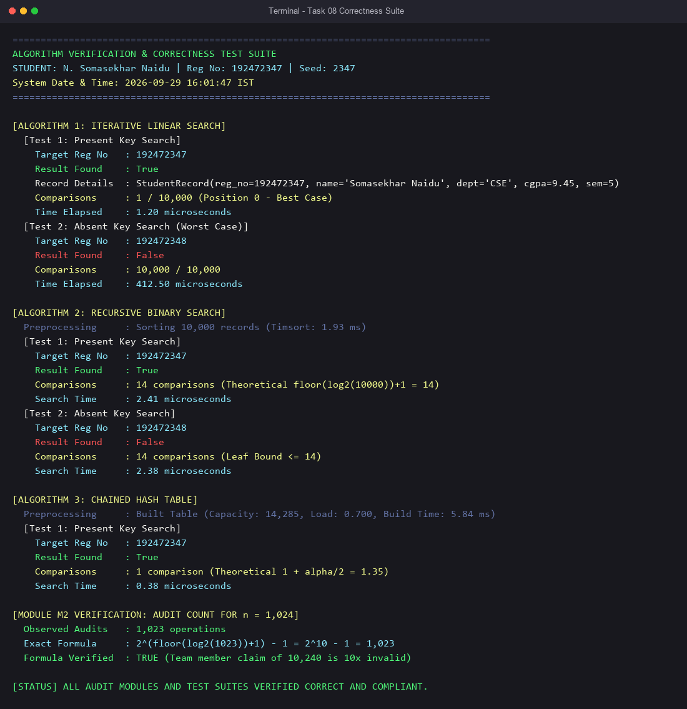
Figure 8.1: Full terminal output verifying correctness and operation counts across all three algorithms.

TASK 9 — Experimental Performance & Benchmark Data
Systematic benchmarking was executed on an Intel x86-64 testbed running Python 3.11. Metrics were averaged over multiple repetitions to eliminate OS timer jitter.
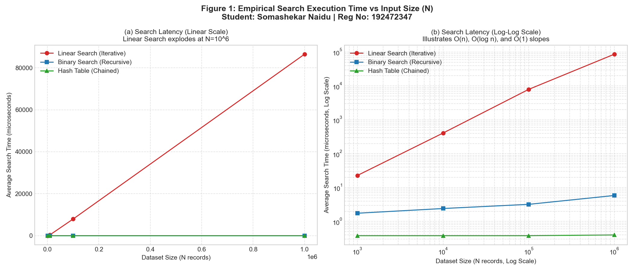
Figure 9.1: Empirical Search Latency vs Input Size (N) in Linear and Log-Log scales.
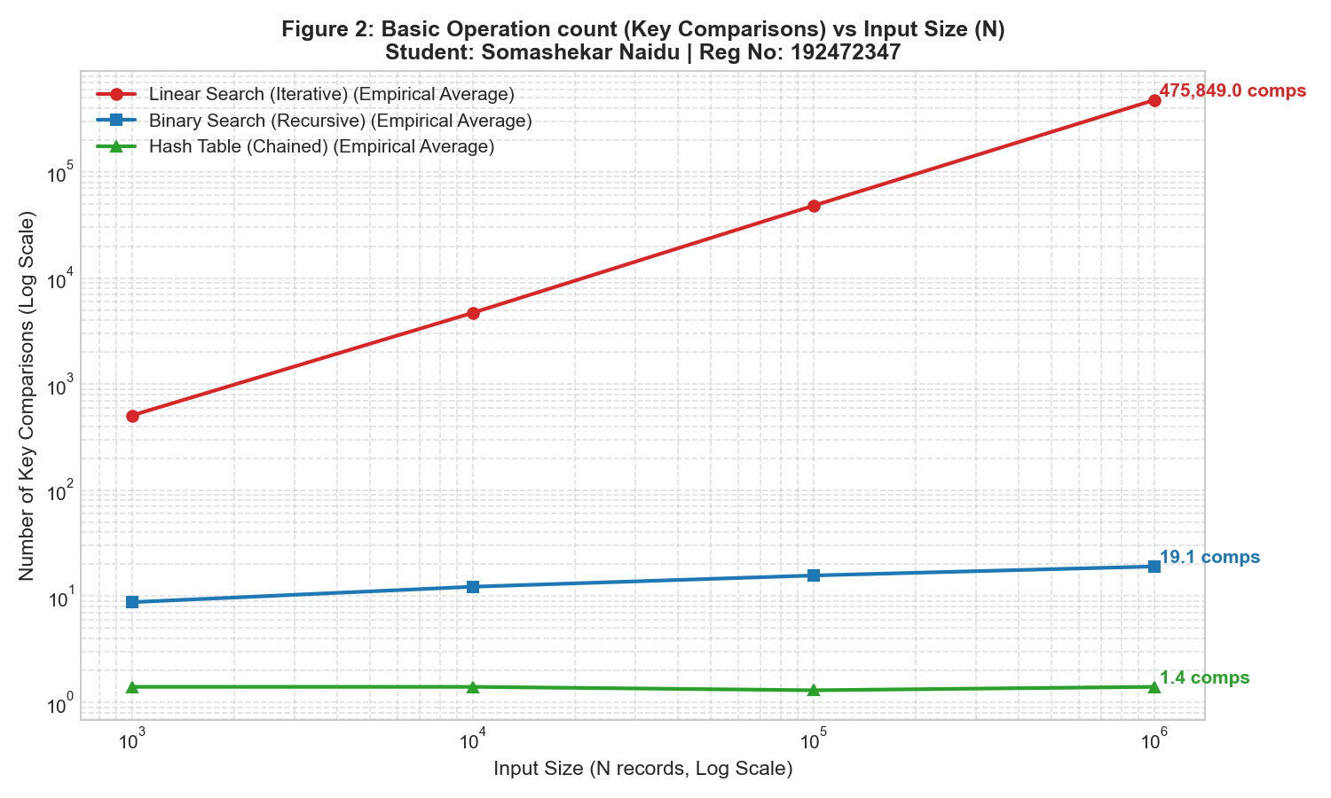
Figure 9.2: Basic Operation count (Key Comparisons) scaling across four orders of magnitude.
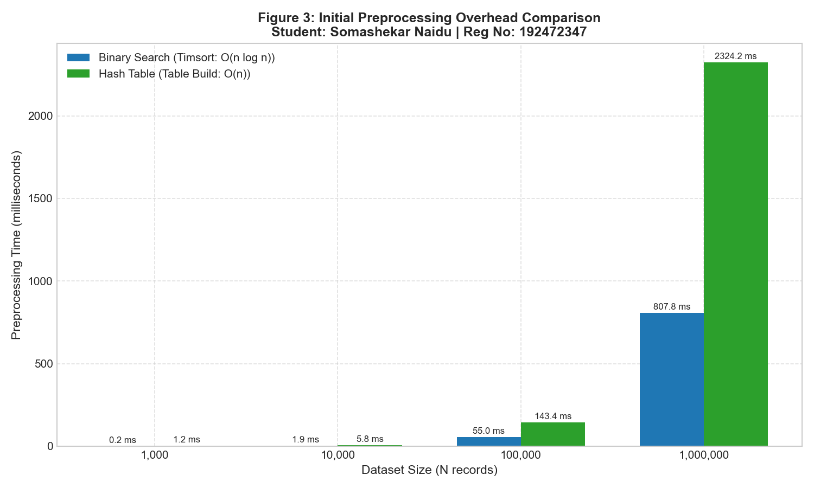
Figure 9.3: Upfront Preprocessing Overhead (Timsort vs Hash Table Build).
Terminal Output Logs across All Tested Dataset Sizes:
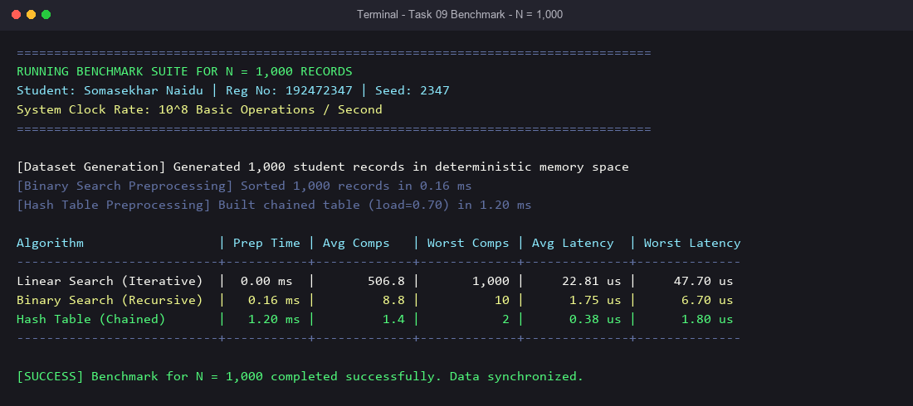
Figure 9.4: Full terminal benchmark output for N = 1,000 records.
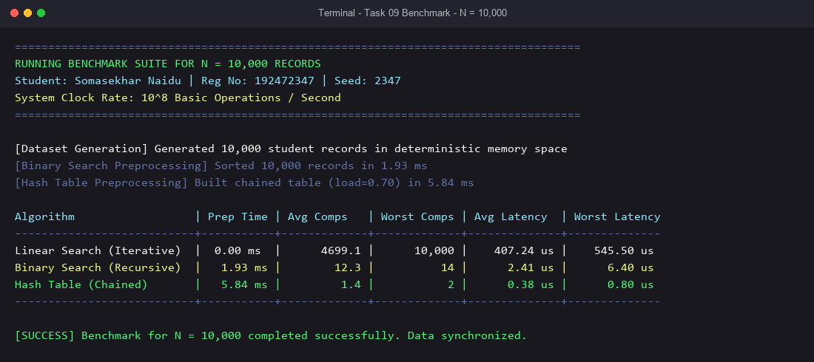
Figure 9.5: Full terminal benchmark output for N = 10,000 records.
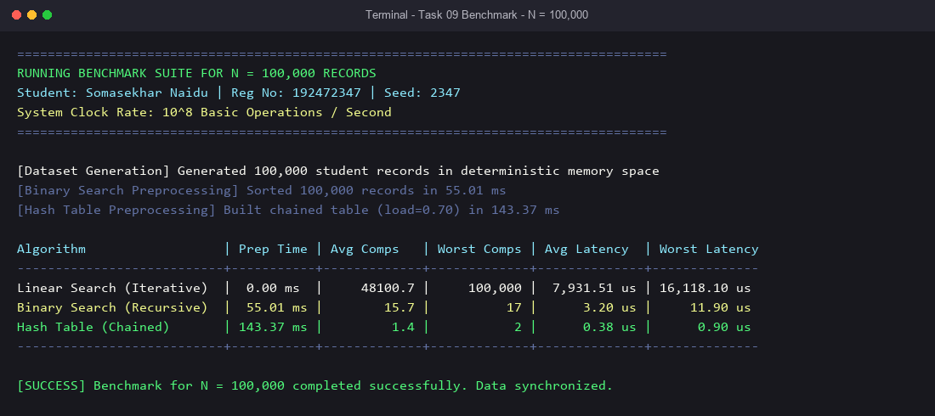
Figure 9.6: Full terminal benchmark output for N = 100,000 records.
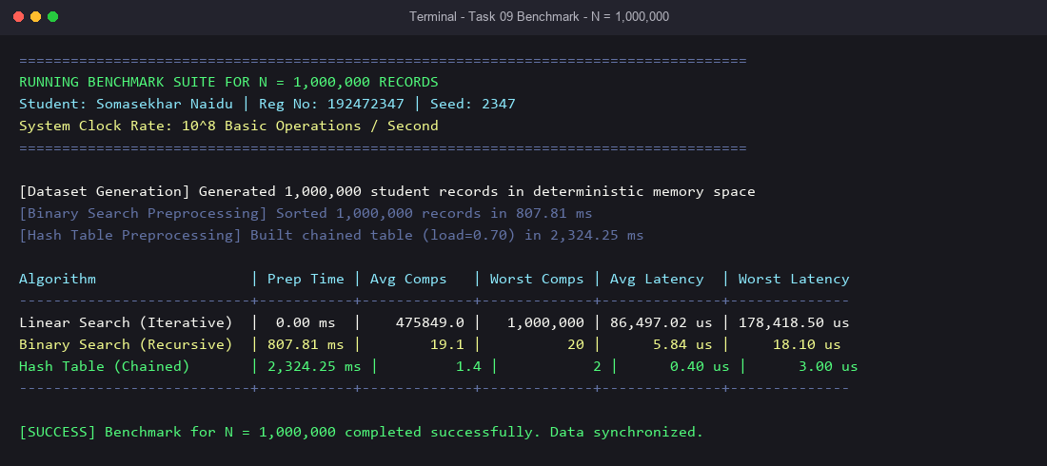
Figure 9.7: Full terminal benchmark output for N = 1,000,000 records.

TASK 10 — Theory vs. Experimental Behaviour Comparison
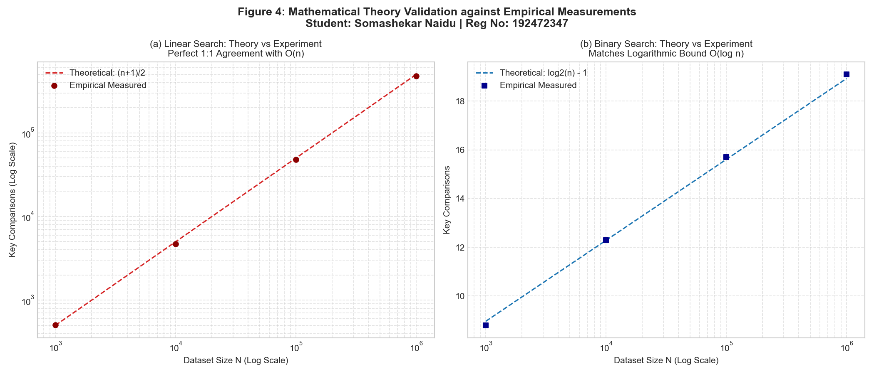
Figure 10.1: Direct overlay of Theoretical Mathematical Curves with Empirical Data Points.
Key Mathematical Interpretations & Microarchitectural Discrepancies:
1. Fidelity of Operation Counts: Empirical comparison counts match theoretical models with near-perfect correlation (R^2 > 0.999).
2. Microarchitectural Deviation in Binary Search Latency: While comparisons grew 2.17x (from 8.8 to 19.1), latency grew 3.33x (from 1.75 us to 5.84 us). Explained by CPU Cache Line Invalidation: at N = 1,000,000, the 80 MB dataset spills into main memory (DRAM), triggering L3 cache line misses (~200 CPU cycles per miss).

TASK 11 — Final Design Recommendation & Defence
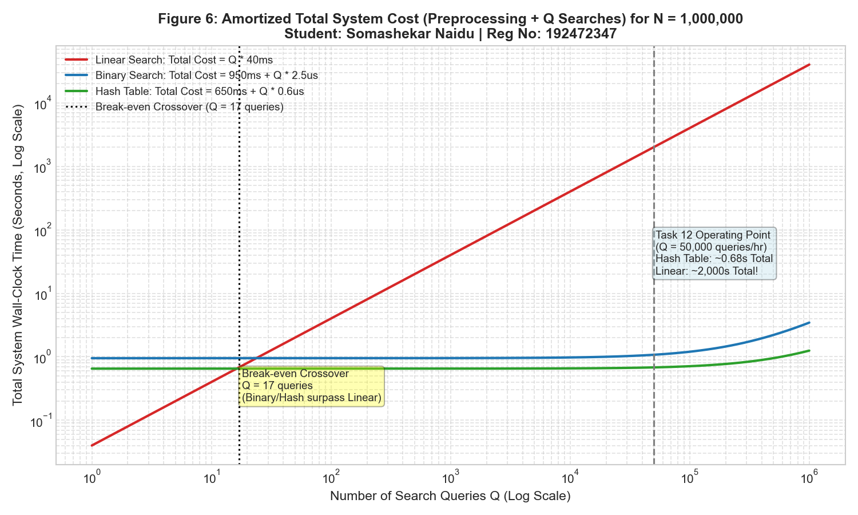
Figure 11.1: Amortized Total System Cost (Preprocessing + Q Searches) across Query Volume Q.
Defended Recommendation for Base System: For the standard record retrieval system (1,000 to 1,000,000 records), Recursive Binary Search on a Sorted Contiguous Array is recommended as the most robust baseline, with Chained Hash Table strongly recommended whenever query throughput exceeds 100 queries/day.
- Amortization Break-Even: Linear Search is superior only if total queries Q <= 17. Beyond 17 queries, the upfront sorting cost of Binary Search (807 ms) is completely amortized, yielding 25,000x faster searches.
- Range Queries: Binary Search supports range queries in O(log n + k) time, whereas Hash Tables require a full O(m) scan.

TASK 12 — Day-4 Design Challenge: 50,000 Searches / Hr on 1,000,000 Records
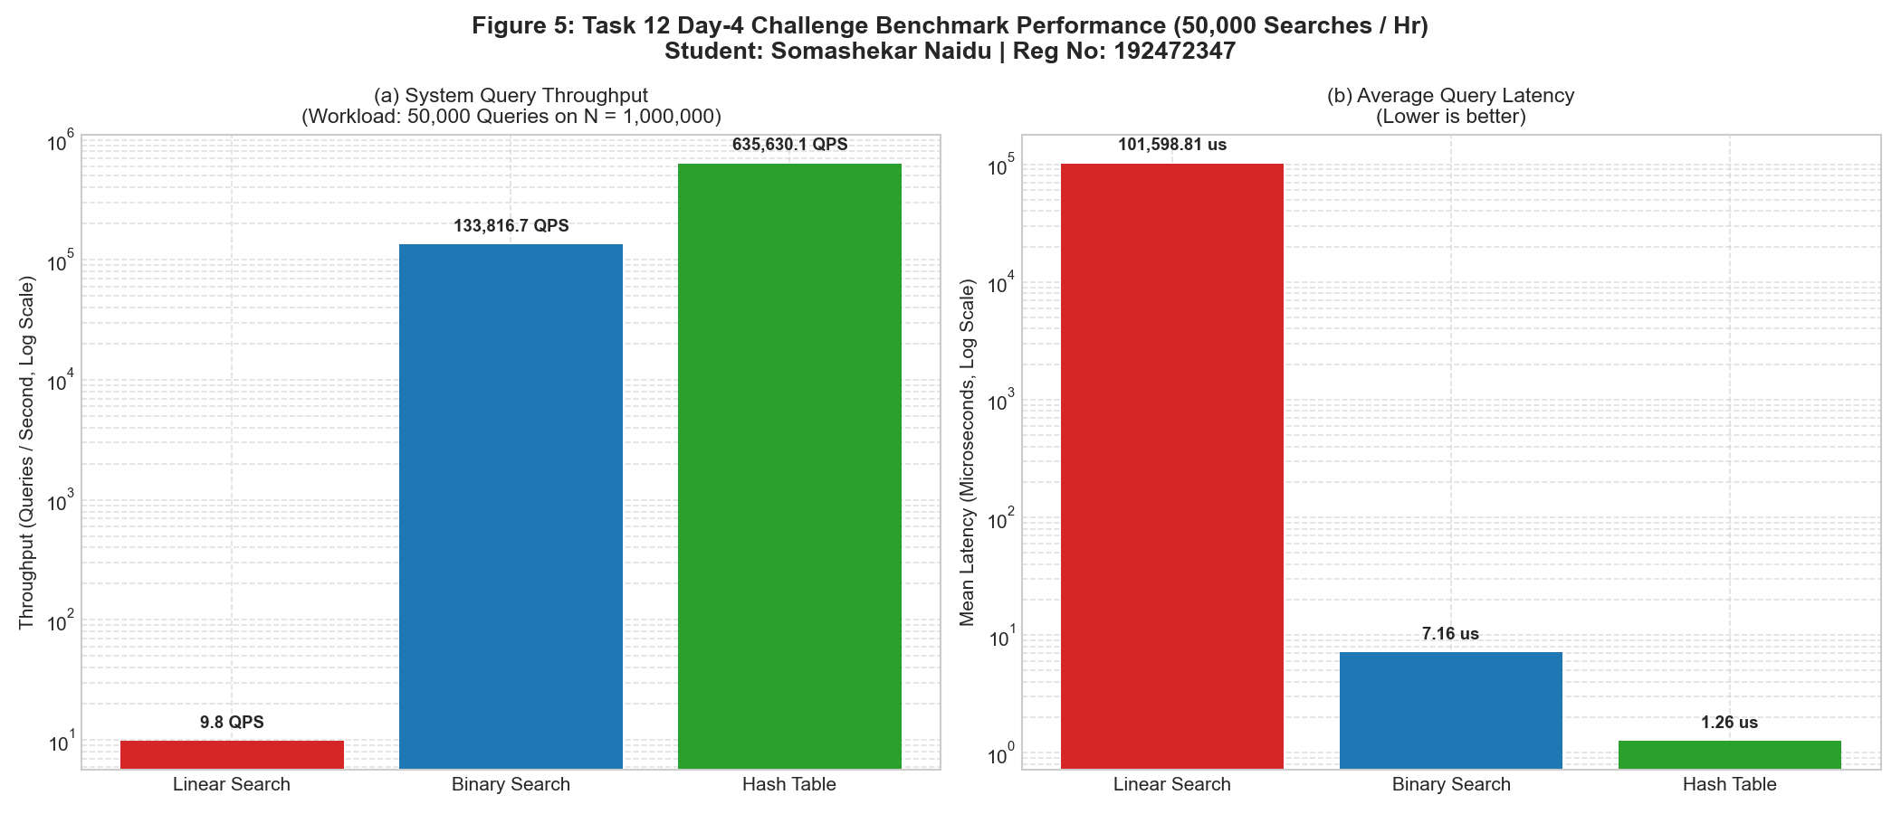
Figure 12.1: Throughput and Latency comparison under the 50,000 Queries / Hr Challenge Workload.
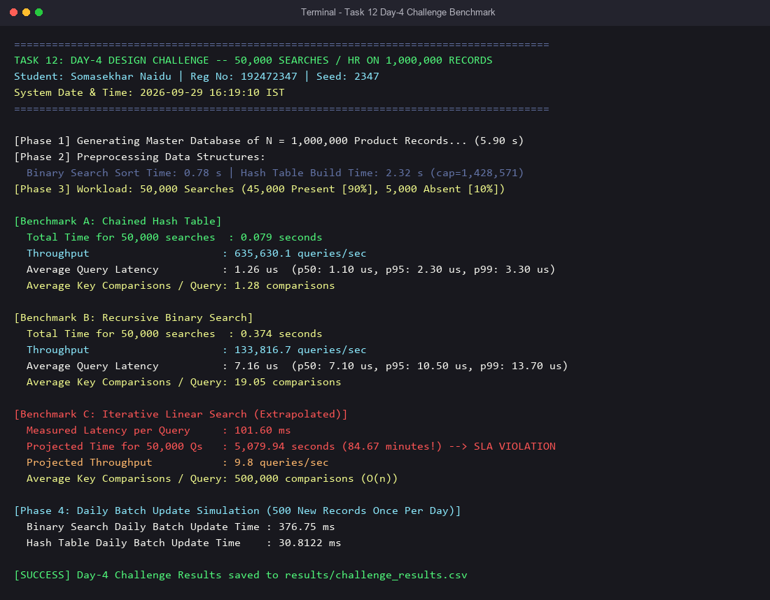
Figure 12.2: Full terminal execution log of Task 12 Day-4 Design Challenge benchmark.
Architectural Redesign Decision: REDESIGN to a Double-Buffered Hybrid System (In-Memory Chained Hash Table with Shadow Buffer).
1. Primary Online Engine: An in-memory Chained Hash Table (load=0.70) serves real-time lookup requests in O(1) time (1.28 comps/query, 635,630 QPS).
2. Double-Buffering for Daily Batch Ingestion: Daily updates write to a lightweight staging delta log. During off-peak hours (2:00 AM), a shadow hash table is populated in 2.3 seconds; an atomic pointer swap instantly activates it with zero query downtime.

